Assignment 1
Instructions
Each of your readings for this unit reinforces the contention that theory, culture, and image are words and concepts that have various meanings and uses that may contradict and/or compete with each other. In this web discussion, we return to three of the pictures we have looked at in the unit to think further about how cultures as “worlds of meaning” are formed in language and how language and cultural contexts inform images.
Look at the works listed and answer the following set of questions for each, taking into consideration the issues you have studied and using the vocabulary you have learned in Unit 1:

- Egon Schiele, Self-Portrait with Spread Fingers, 1911 (see below)
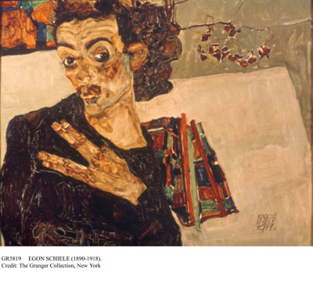
- Duck/Rabbit, 1899 (see Unit 1, Topic 3)
- 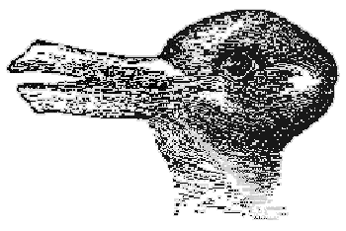
- Weegee, Their First Murder, 1941 (see Unit 1, Topic 3)
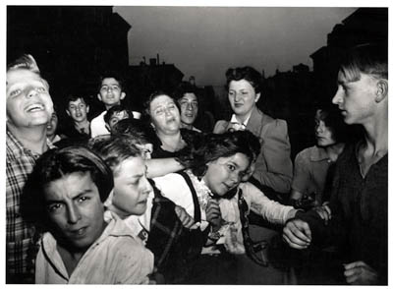
[d]

Questions
For each of the three works listed above, answer the following set of questions.
- Without the title or other information provided, how would you interpret the image?
- What difference do you think the viewer's cultural background would make to the interpretive process?
- How does cultural knowledge change how we make meaning from an image?
- What other meanings might be made?
Criteria for Evaluating Contributions to Unit 1 Web Discussion
Refer to the general criteria for evaluating contributions to web discussions. In addition, your contributions to the Unit 1 discussion should total approximately 400–500 words (spread over a minimum of two contributions).

SAMPLE of STUDENTS WORK

Egon Schiele, Self-Portrait with Spread Fingers
The muted colours and expressionist style lend an otherworldly quality to the painting. The subject of the painting, the figure of the person with the spread fingers becomes ambiguous. Their gender is questionable, as is their expression. The figure has the qualities of a man, such as the suggestion of a moustache and flat chest, but is positioned in a way subverts the representation of a traditional masculine figure. The sloping shoulder de-emphasizes what could be a more masculine, broad-shouldered shape. The mass beside the figures head could either be long, curly hair, or something in the background. The figure is not posed in a traditionally masculine, dominant way, but is instead positioned in a more self-effacing way.
I am inclined to believe that the image is a self-portrait, for the sole reason that it is unflattering. The muddy, indistinct colours and distorted body position convey a negative image of the subject. It seems likely to me that this reflects a negative self-image on the part of the artist.
The cultural background of the viewer could have a profound impact on the interpretation of the image. I imagine that there could be a generation gap in understanding the image. The current generation of young adults may be more accustomed to grappling with representations of gender and sexuality fluidity. Such a group may focus on these themes in the image more readily than a group of people of an older demographic more used to encountering traditional binary representations of gender and sexuality. The different types of cultural knowledge act as lenses through which the artwork is viewed.
Other meanings of the painting include the negative self-image of the artist. He presents himself looking sickly, thin, and unbalanced on the canvas.
Duck/Rabbit
Without knowing anything about the image, a first interpretation may be that it is solely an image of a duck, or a rabbit exclusively. Seeing both, I would interpret the image as a kind of game or trick. It is a rather simple image, just the drawn head of an animal, but the way that the both the duck and the rabbit are both accurately represented through the same form marks it as something other than a quick sketch or study. I have seen other images that attempt the same thing, but this is the simplest, most effective one.
Even in such a simple image, I can imagine that there are various interpretations. While some may see it as a game, others may see it as more of a statement on the reliability of representation, and how everything has multiple meanings whether we realize it or not. Another possible interpretation is from an ecological approach, considering that the image represents animals, it could possibly be a statement on the interconnections within the natural world.
Of the three images studied in this assignment, this one seems likely to be the most universally interpreted depending on the viewers culture. The main
difference that I think there might be is that people see a different animal first, depending on which one most closely resembles a common animal in their location. As well, depending on their depth of study into art and cultural theory, people may not interpret the image as anything more than a trick.

Weegee, Their First Murder
Weegee's photograph reminds me of contemporary club photography. It's like the kind of scene you may capture at a party or an event when no one is expecting the flash of a camera in their face. The expressions of the subjects captured don't seem contrived at all, having likely not had any time to compose themselves for a photo. The young people in the photo have such varied expressions, from unrestrained happiness to confusion to anger. The event that these people are involved in is unknown, and is left ambiguous from the range of reactions shown in the subjects. It seems to be taken in the midst of a contentious event. Some people are scowling, and others are smiling. Few of the people are focused on the camera. Because of the variation of expressions and the candid nature of the photograph, I am not able to determine whether they are reacting to some collective event or each to their own personal dramas.
I think that the different cultural backgrounds of the viewers would change the interpretation of the event that is occurring in the photo. As a North American millennial, my first frame of reference for the photo was to compare it to contemporary event photography at clubs and parties. Somebody alive in the 60s and 70s may see it as an image of people at a protest or riot. I think that these would be the two most common interpretations of the image, that it is either a party or a riot. This party/riot distinction could also be geographic. Depending on what event is more common in the viewer's locale, it may colour their interpretation of the image. It is inevitable that we use our own experiences as a reference for understanding images and photographs especially, and the things we have more experience with depending on our culture, influences how we see unfamiliar events.

